

**Kathmandu College of Technology**

**Lokanthali, 16 Bhaktapur**

Lab Reports On

**OOP in java**

**(CACS-204)**

Faculty of Humanities and Social Sciences

Tribhuvan University

Kirtipur, Nepal

Date: Total No. of Experiment: 6

Submitted By: Submitted To:

Name: Department of BCA

Roll No: -

Faculty: Bachelor in Computer Application -

Year//Part: 2nd Year, 2077 // 3rd Semester (Lecturer/Supervisor)

TABLE OF CONTENTS

|  |  |
| --- | --- |
| Lab No. | TOPIC |
| Lab 1 | Lab Exercise 1 Using IntelliJ-IDEA Software with JDK |
| Lab 2 | Lab Exercise 2 Using IntelliJ-IDEA Software with JDK |
| Lab 3 | Lab Exercise 3 Using IntelliJ-IDEA Software with JDK |
| Lab 4 | Lab Exercise 4 Using IntelliJ-IDEA Software with JDK |
| Lab 5 | Lab Exercise 5 Using IntelliJ-IDEA Software with JDK Netbeans and AppletViewer |

( lab 1 to 5 is present in other document edit it as your need.)



**Kathmandu College of Technology**

**Lokanthali, 16 Bhaktapur**

**Lab Report On**

**OOp in java**

**(CACS-204)**

**(Using IntelliJ-IDEA Software with JDK)**

Date: No. of Experiment: # 01

Submitted By: Submitted To:

Name: Department of BCA

Roll No: -

Faculty: Bachelor in Computer Application (Lecturer/Supervisor)

Year//Part: 2nd Year, 2077 // 3rd Semester

TABLE OF CONTENTS

* Write a java program to find greater number among three numbers.
* Write a java program to print odd and even numbers up to 100.
* Write a java program to print the prime numbers up to 100.
* Write a java program to print Fibonacci series up to 100.
* Write a java program to perform arithmetic operator uses.
* Write a java program to swap two numbers without using third variable.
* Write a java program to print:-

*********

*******

*****

***

*

* Write a java program to create jagged array and use it.
* Write a java program to perform matrix addition.
* Write a java program to perform matrix multiplication.
* Write a java program to use jumping statements i.e. break and continue.
* Write a java program to use command line arguments.
* Write a java program to sort the number in descending order.
* Write a java program to print:-

11111

2222

333

44

5

66

777

8888

99999

15. Write a java program to perform typecasting.

**Lab Exercise 1**

* Write a java program to find greater number among three numbers.

Program:-

|  |
| --- |
| public class Max {  public static void main(String[] args)  {  int a = 3; b = 2; c = 4;  if (a > b)  {  if (a > c)  System.out.println("The greatest number is " + a);  else  System.out.println("The greatest number is " + c);  }  else if (b > c)  System.out.println("The greatest number is " + b);  else  System.out.println("The greatest number is " + c);  }  } |

Output:-

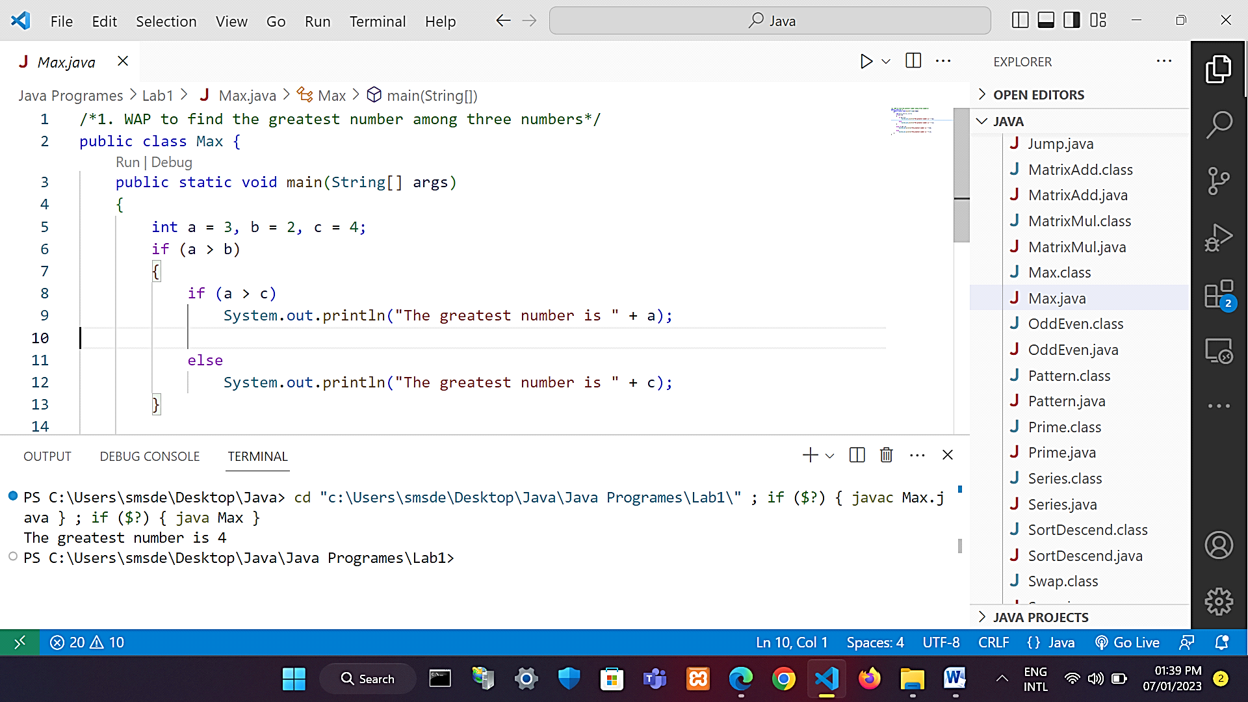

* Write a java program to print odd and even numbers up to 100.

Program:-

|  |
| --- |
| public class OddEven {  public static void main(String[] args)  {  System.out.println("The even number up to 100:");  for (int i = 0; i <= 100; i++)  {  if (i % 2 == 0)  System.out.print(i + ", ");  }  System.out.print("\n");  System.out.println("\nThe odd number up to 100:");  for (int i = 0; i <= 100; i++)  {  if (i % 2 != 0)  System.out.print(i + " ");  }  }  } |

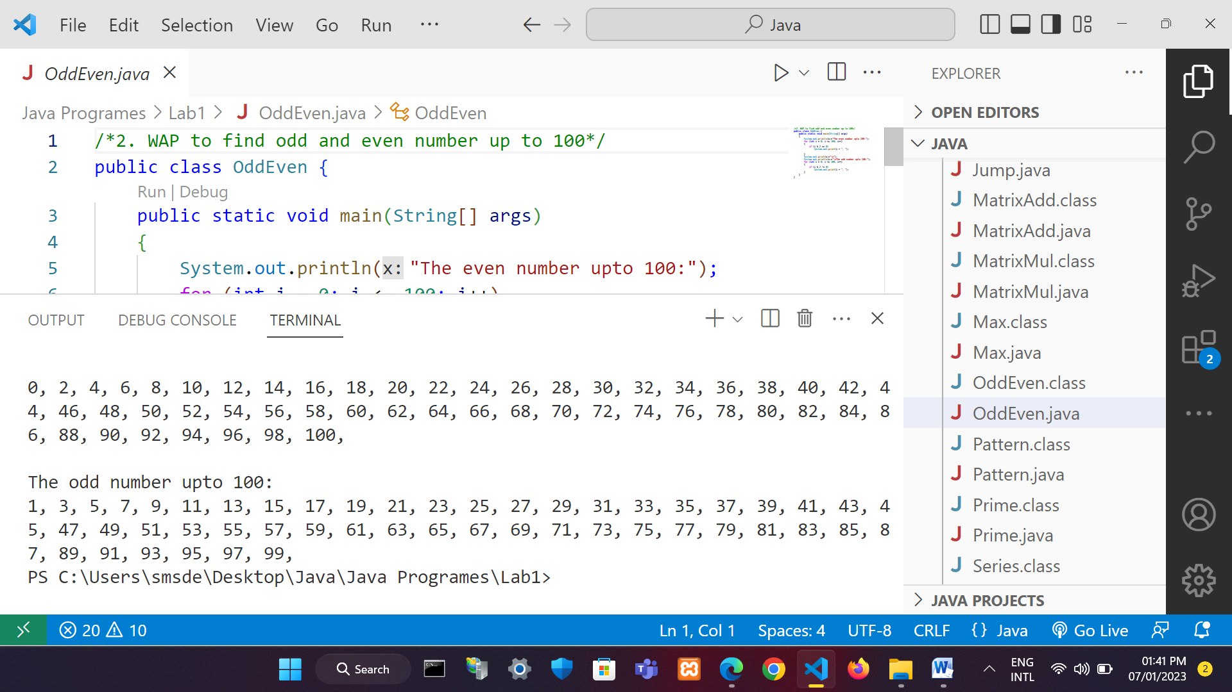Output:-

* Write a java program to print the prime numbers up to 100.

Program:-

|  |
| --- |
| public class Prime  {  public static void main(String[] args) {  int a=1,b=100;  for(int i=a;i<=b;i++){  if(checkPrime(i)){  System.out.print(i+" " );  }  }  }  public static boolean checkPrime(int num){  if(num<2){  return false;  }  else{  int x= num/2;  for(int i=2;i<x;i++){  if(num%i==0){  return false;  }  }  }  return true;  }  } |

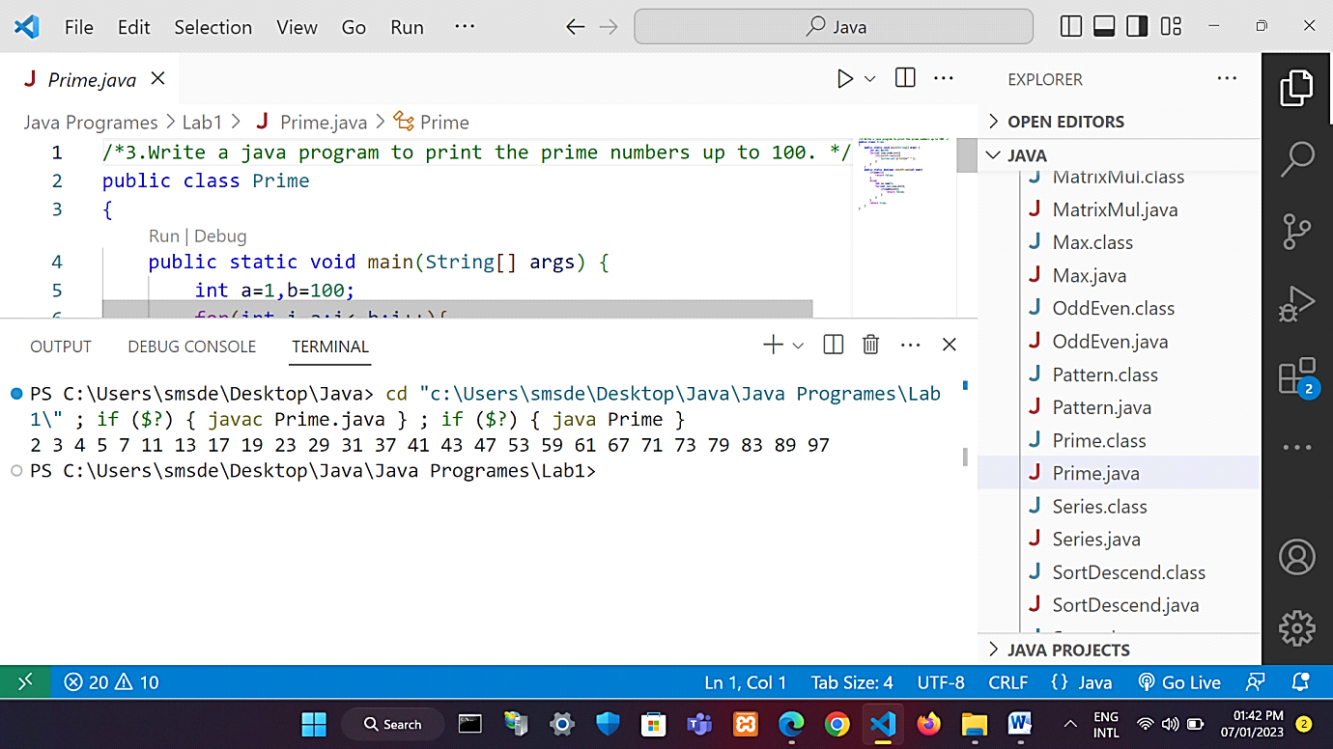Output:-

* Write a java program to print Fibonacci series up to 100.

Program:-

|  |
| --- |
| public class Series {  public static void main(String[] args)  {  int n1 = 0, n2 = 1, num, i = 0;  System.out.println("Fibonacci Series up to 100");  while (i >= 0) {  num = n1 + n2;  System.out.print(n1 + " ");  n1 = n2;  n2 = num;  if (n1 >= 100) {  break;  }  i++;  }  }  } |

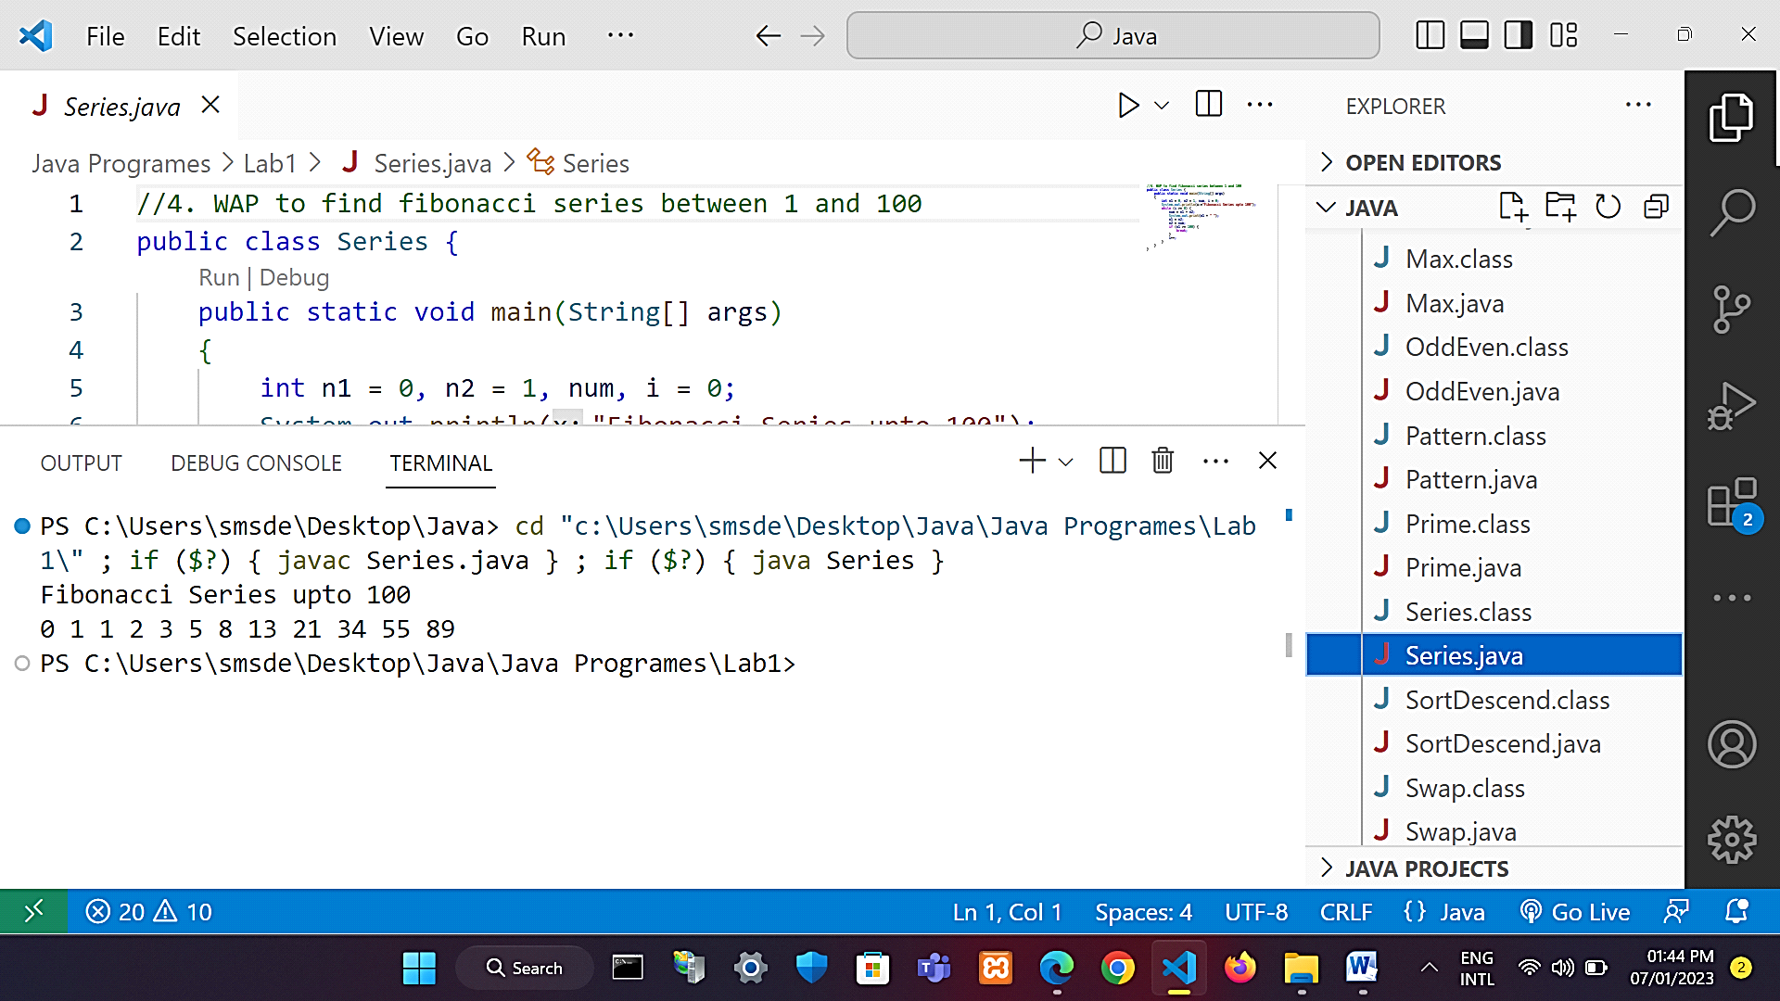Output:-

* Write a java program to perform arithmetic operator uses.

Program:-

|  |
| --- |
| public class Arithmetic {  public static void main(String []args) {  int a = 15, b = 7;  // addition operator  System.out.println("a + b = " + (a + b));  // subtraction operator  System.out.println("a - b = " + (a - b));  // multiplication operator  System.out.println("a * b = " + (a * b));  // division operator  System.out.println("a / b = " + (a / b));  // modulo operator  System.out.println("a % b = " + (a % b));  }  } |

Output:-

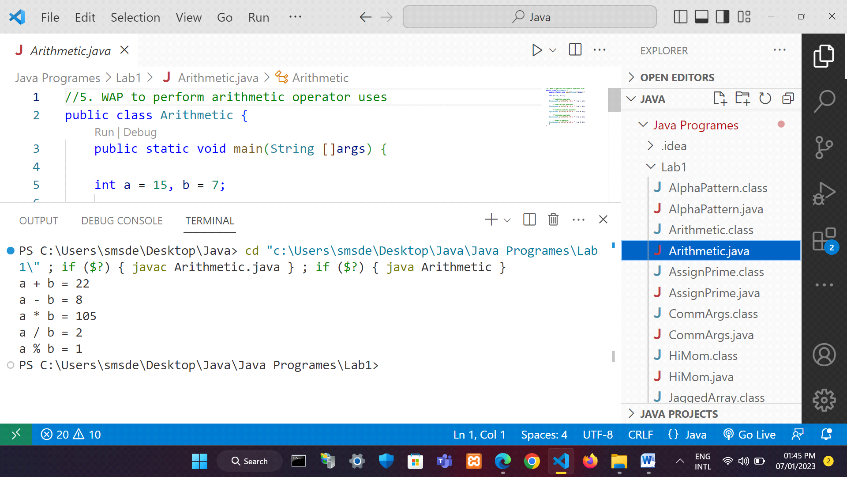

* Write a java program to swap two numbers without using third variable.

Program:-

|  |
| --- |
| public class Swap {  public static void main(String []args) {  int a = 20, b = 15;  System.out.println("Before Swap: " + "a: " + a + ", b: " + b);  a = a + b;  b = a - b;  a = a - b;  System.out.println("After Swap: " + "a: " + a + ", b: " + b);  }  } |

Output:-

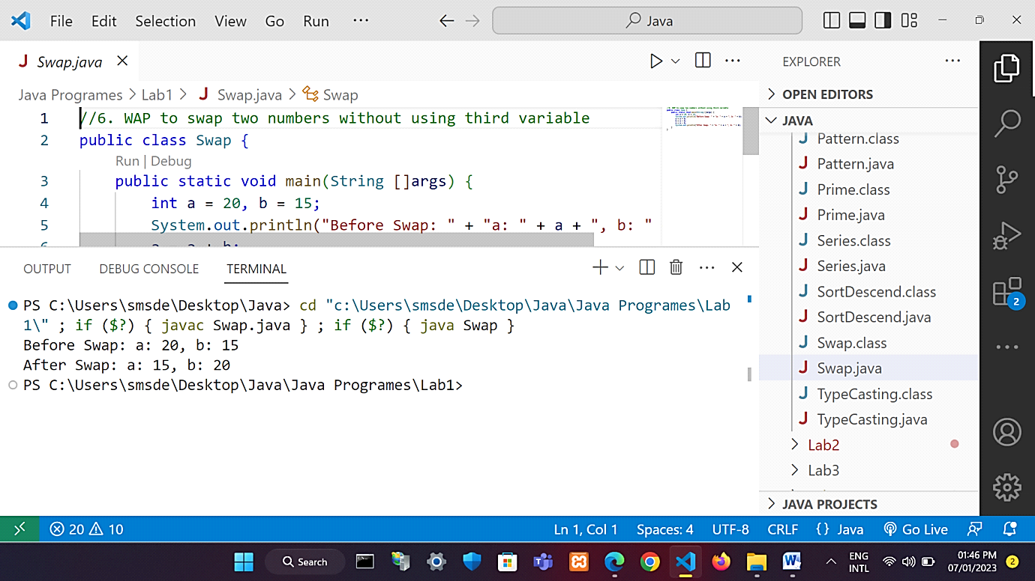

* Write a java program to print-

*********

*******

*****

***

*

Program:-

|  |
| --- |
| public class Pattern {  public static void main(String[] args) {  int num = 5;  int i, j;  for(i = num; i >= 1; i--) {  for(j = i; j < num; j++) {  System.out.print(" ");  }  for(j = 1; j <= (2 * i - 1); j++) {  System.out.print("*");  }  System.out.println(" ");  }  }  } |

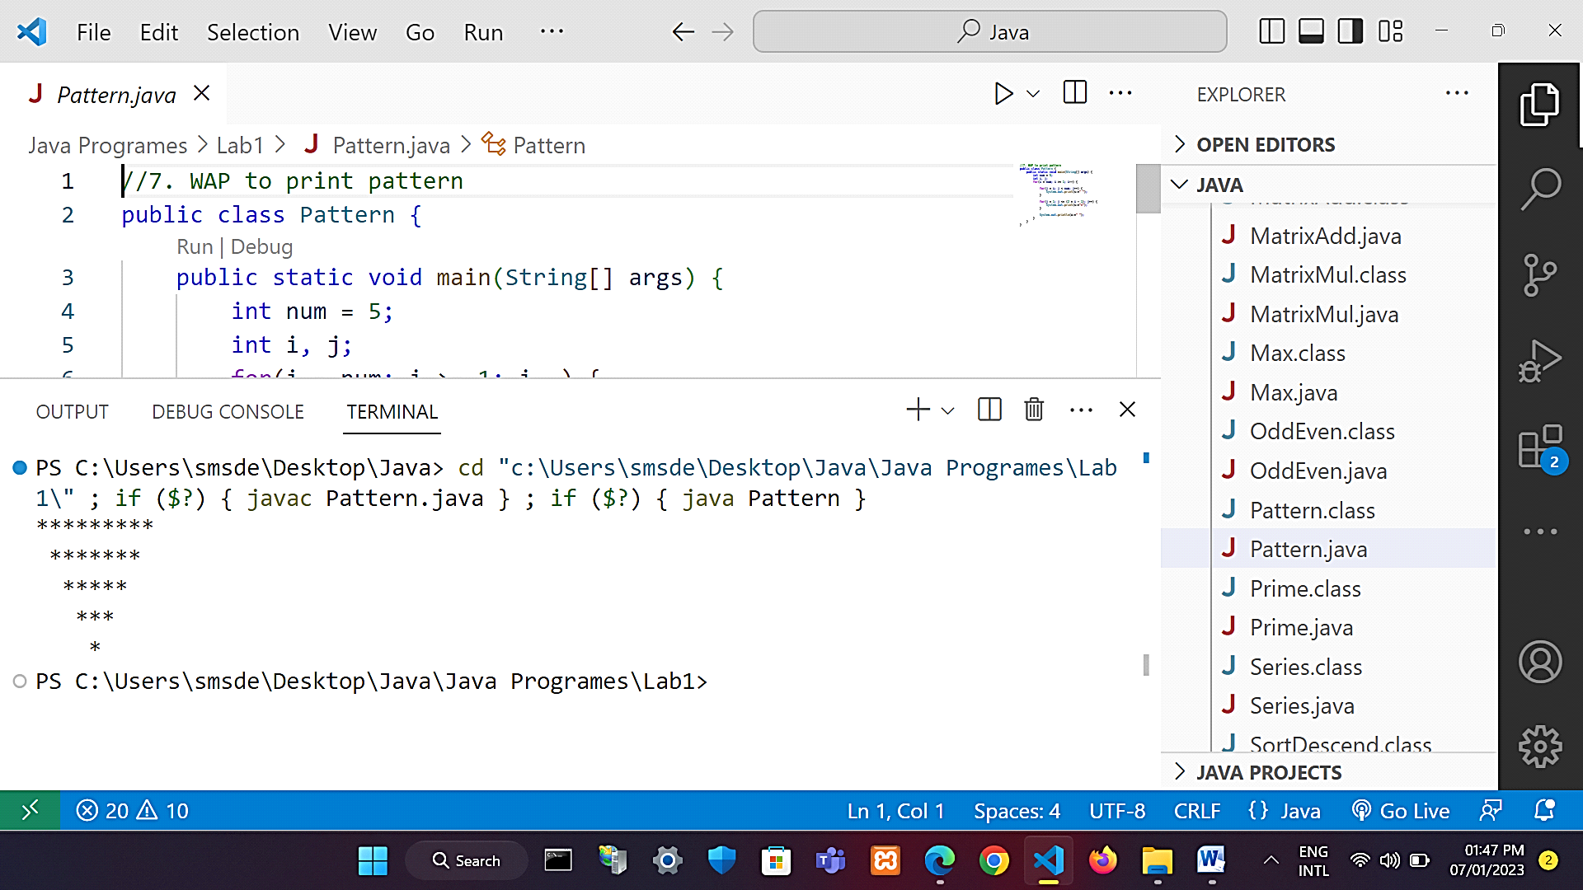

Output:-

* Write a java program to create jagged array and use it.

Program:-

|  |
| --- |
| public class JaggedArray {  public static void main(String []args) {  int [][]arr = new int[4][];  arr[0] = new int[1];  arr[1] = new int[2];  arr[2] = new int[3];  arr[3] = new int[4];  int count = 0;  for (int i = 0; i < arr.length; i++)  for (int j = 0; j < arr[i].length; j++)  arr[i][j] = count++;  System.out.println("Contents of 2D Jagged Array:");  for (int i = 0; i < arr.length; i++) {  for (int j = 0; j < arr[i].length; j++)  System.out.print(arr[i][j] + " ");  System.out.println();  }  }  } |

Output:-

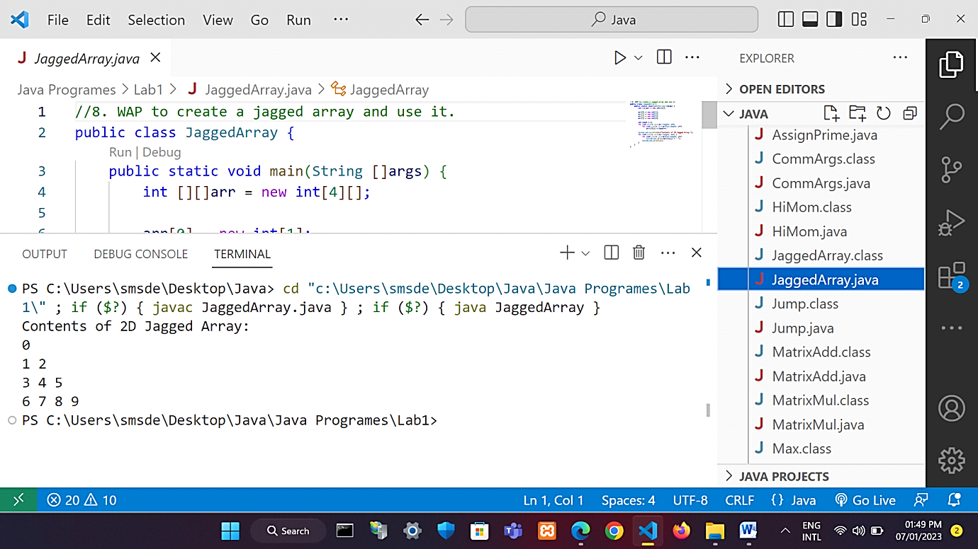

* Write a java program to perform matrix addition.

Program:-

|  |
| --- |
| public class MatrixAdd {  public static void main(String []args) {  int [][]a={{1,2,3},{4,5,6},{7,8,9}};  int [][]b={{1,3,4},{2,4,3},{1,2,4}};  int [][]c=new int[3][3];  System.out.println("Matrix Addition: ");  for(int i=0;i<3;i++) {  for(int j=0;j<3;j++) {  c[i][j]=a[i][j]+b[i][j];  System.out.print(c[i][j]+" ");  }  System.out.println();  }  }  } |

Output:-

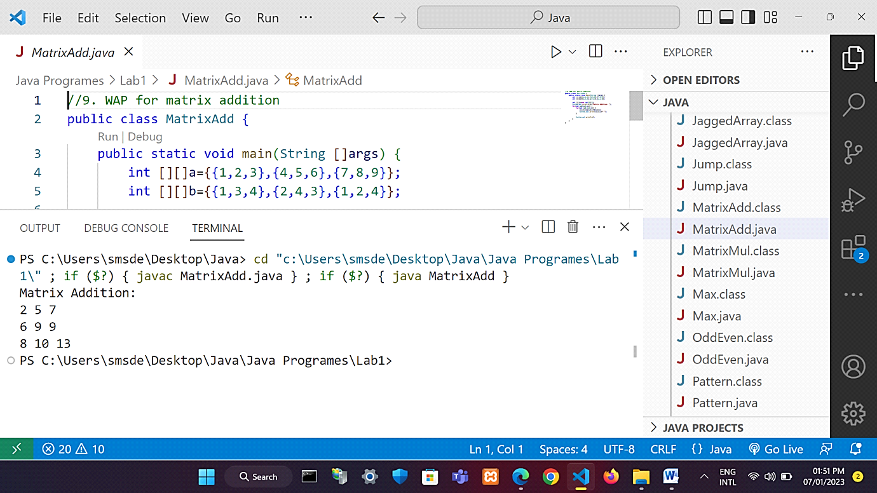

* Write a java program to perform matrix multiplication.

Program:-

|  |
| --- |
| public class MatrixMul {  public static void main(String []args) {  int [][]a = {{1,2,3}, {4,5,6}, {7,8,9}};  int [][]b = {{1,3,4}, {2,4,3}, {1,2,4}};  int [][]c = new int[3][3];  System.out.println("Matrix Multiplication: ");  for(int i = 0; i < 3; i++){  for(int j = 0; j < 3; j++){  c[i][j] = 0;  for(int k = 0; k < 3; k++)  {  c[i][j] += a[i][k] * b[k][j];  }  System.out.print(c[i][j]+" ");  }  System.out.println();  }  }  } |

Output:-

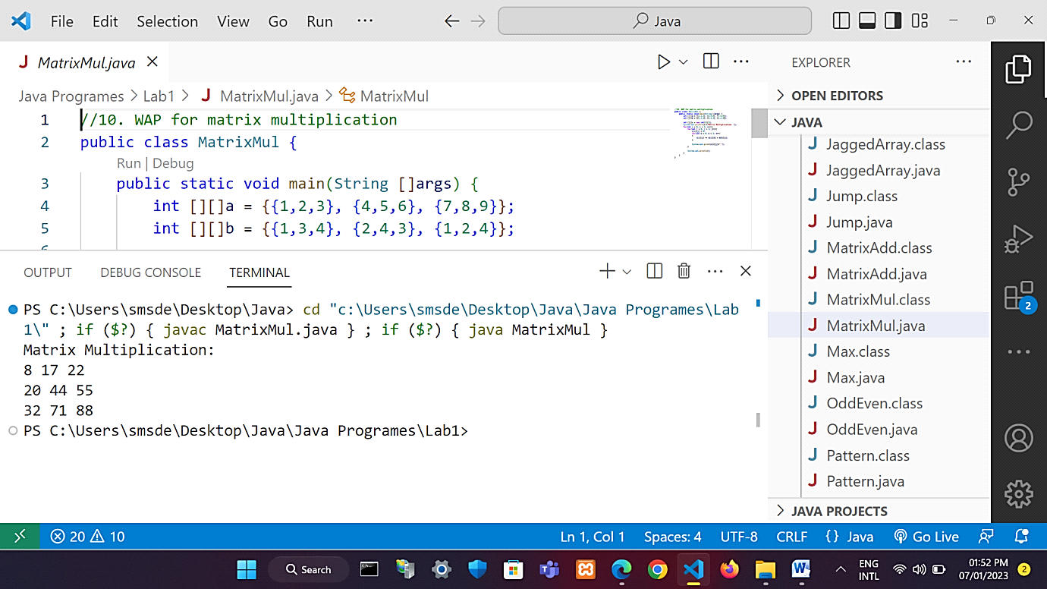

* Write a java program to use jumping statements i.e. break and continue.

Program:-

|  |
| --- |
| public class Jump {  public static void main(String []args) {  System.out.println("Break Statements: ");  for (int i = 0; i < 10; i++) {  if (i == 7)  break;  System.out.print(i);  }  System.out.println("\n");  System.out.println("Continue Statements: ");  for (int i = 0; i < 10; i++) {  if (i == 7) {  System.out.println("-");  continue;  }  System.out.println(i);  }  }  } |

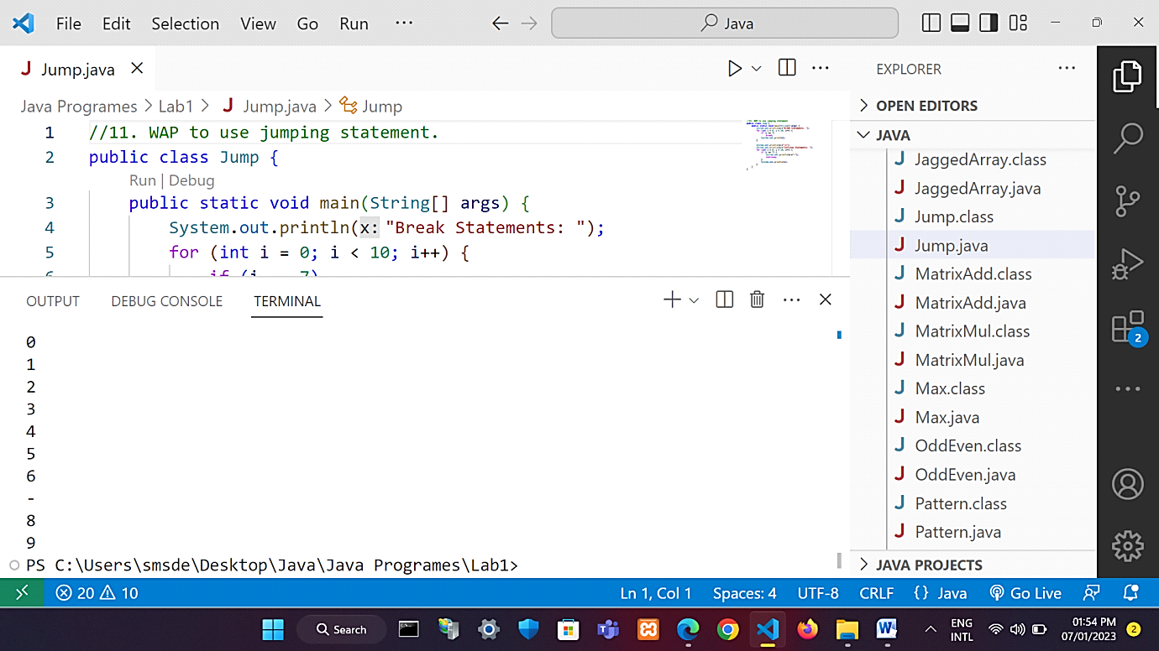Output:-

* Write a java program to use command line arguments.

Program:-

|  |
| --- |
| public class CommArgs {  public static void main(String args[]){    for(int i=0;i<args.length;i++)  System.out.println(args[i]);    }  } |

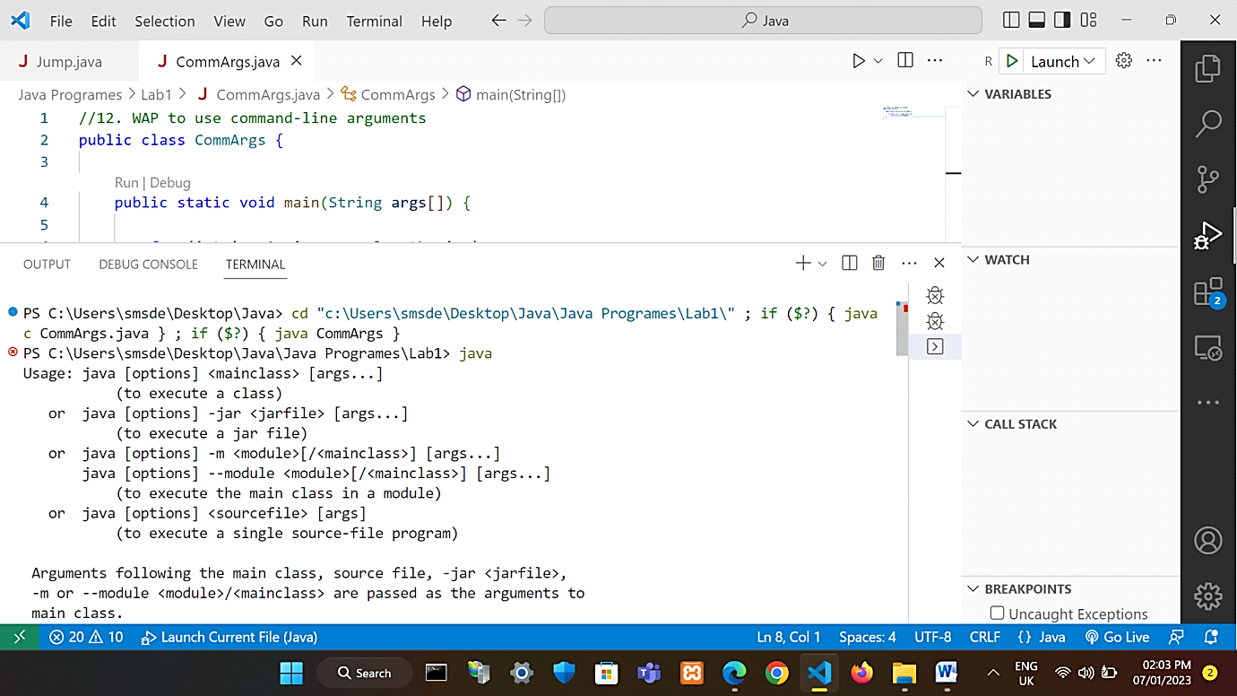Output:-

* Write a java program to sort the number in descending order.

Program:-

|  |
| --- |
| public class SortDescend {  public static void main(String []args) {  int []arr = {36,69,35,2,12,420,123};  int n = arr.length;  int temp;  System.out.println("Array Before Bubble Sort:");  for(int i = 0; i < arr.length; i++){  System.out.print(arr[i] + " ");  }  System.out.println();  for(int i = 0; i < n; i++) {  for(int j = 1; j < (n-i); j++) {  if(arr[j-1] < arr[j]) {  temp = arr[j-1];  arr[j-1] = arr[j];  arr[j] = temp;  }  }  }  System.out.println("Array After Bubble Sort:");  for(int i=0; i < arr.length; i++){  System.out.print(arr[i] + " ");  }  }  } |

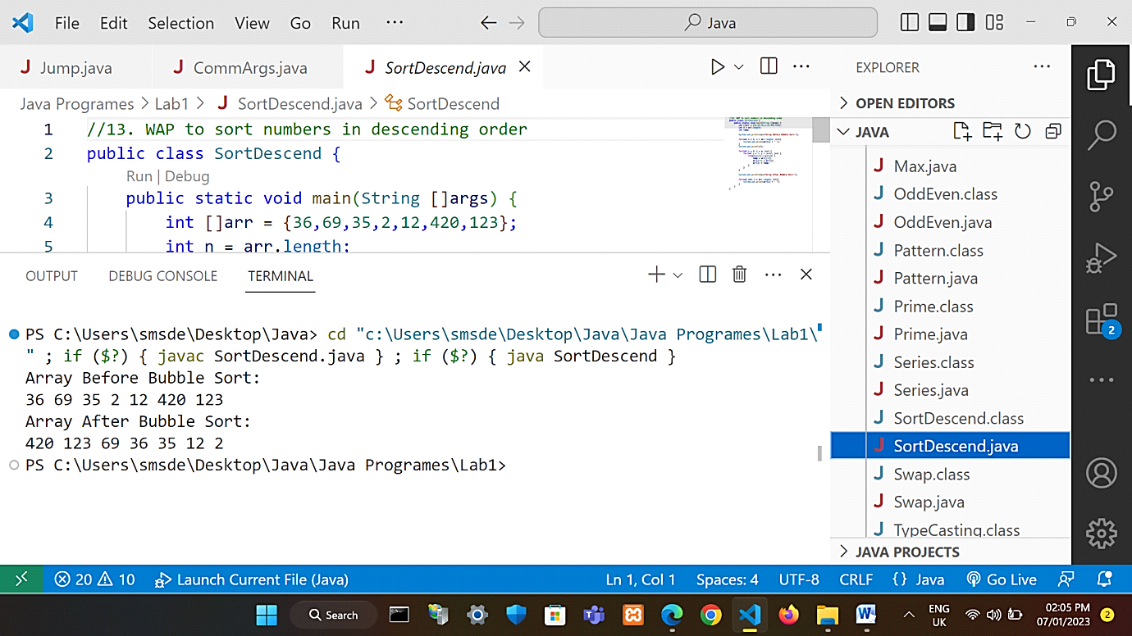Output:-

* Write a java program to print-

11111

2222

333

44

5

66

777

8888

99999

Program:-

|  |
| --- |
| public class AlphaPattern {  public static void main(String []args) {  for (int i = 1; i <= 5; i++) {  for (int j = 5; j >= i; j--) {  System.out.print(i + " ");  }  System.out.println();  }  for (int i = 6; i <= 9; i++) {  for (int j = 2; j <= (i-3); j++) {  System.out.print(i + " ");  }  System.out.println();  }  }  } |

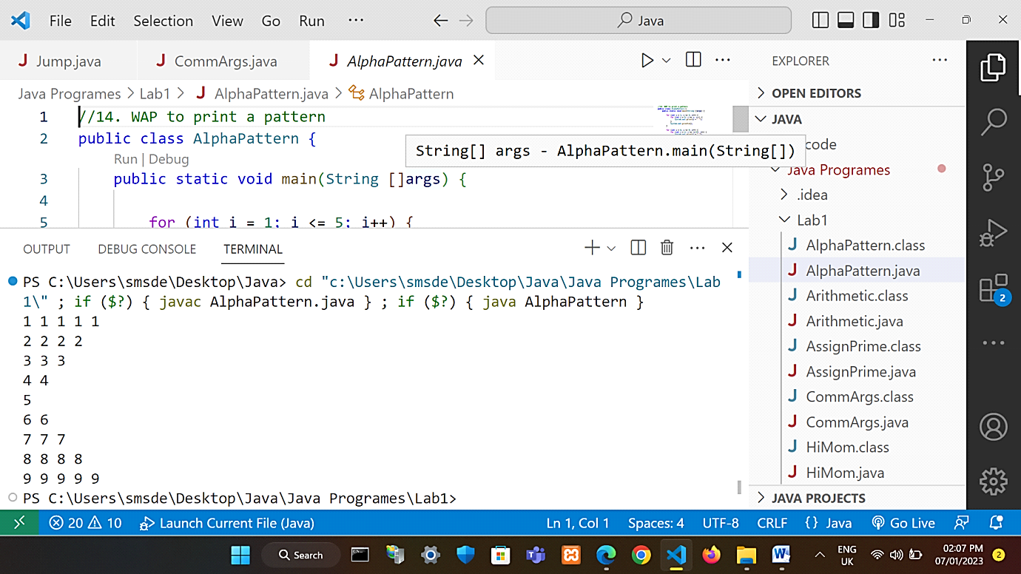Output:-

* Write a java program to perform typecasting.

Program:-

|  |
| --- |
| public class TypeCasting {  public static void main(String []args) {  double d = 420.69;  long l = (long)d;  int i = (int)l;  float f = (float)i;  System.out.println("Before conversion: " + d);  System.out.println("Conversion from double to long type: " + l);  System.out.println("Conversion from long to int type: " + i);  //lost data in typecasting due to narrowing  System.out.println("Conversion from int to float type: " + f);  }  } |

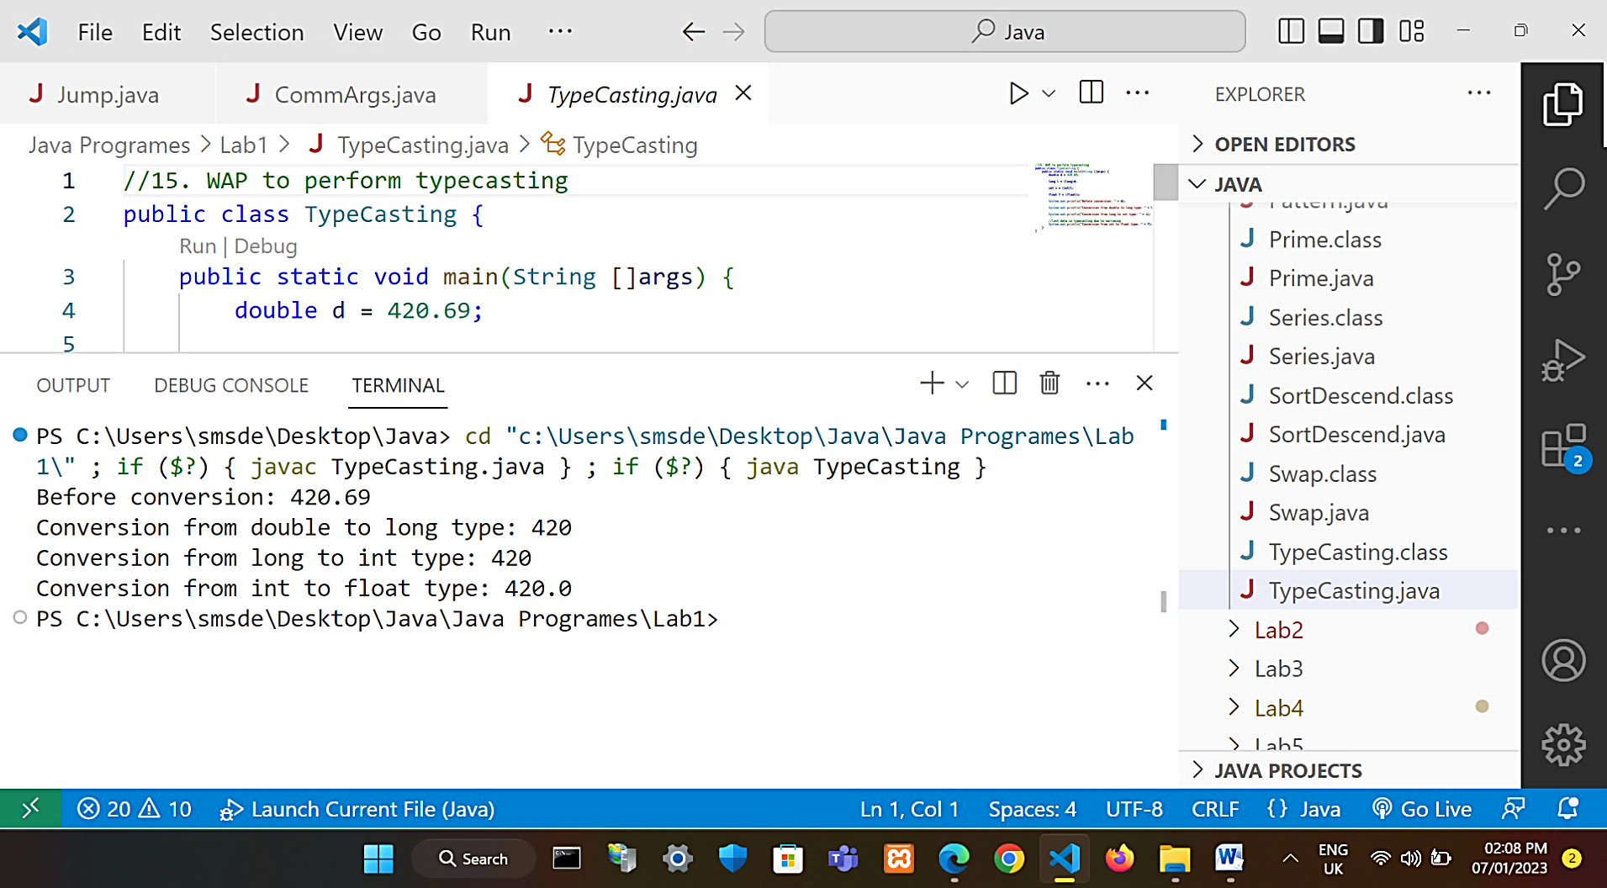Output:-